PHP information retrieval and update with PDO workshop

In this workshop, you are going to re-cap querying MySQL database tables using PHP, but now using PDO to retrieve the records contained and output the results to the web browser. You will then re-cap creating a facility to update records, but again using PDO.

In the following exercises remember that you will then need to upload copies of each file you create onto your web space on the newnumyspace web server and that to test them you need to enter the appropriate web address into the address bar of your web browser.

Exercise 1: creating the database table that we will need
First, we need to import a .sql file that has already been created for you into phpMyAdmin that contains code to create database tables called nc_category, nc_director and nc_movie for use in this workshop.

- From the E-learning portal (Blackboard) download the file northumbriaCinema.sql and save it to your u drive
- Import the sql file using the phpMyAdmin interface (http://phpmyadmin.newnumyspace.co.uk/) to create 3 tables, called ‘nc_category’, ‘nc_director’ and ‘nc_movie’ in your newnumyspace MySQL database
- Use phpMyAdmin to view the structures of the 3 tables. For nc_movie you will see that it contains the following fields for movie records.
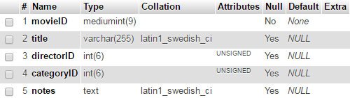

For nc_category you will see the following fields category IDs and the corresponding category names:
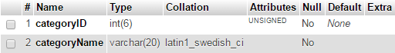

For nc_director you will see the following fields for director IDs and the corresponding director names:
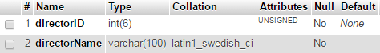
- If you click Browse for each table, you will see the records that they contain.

Exercise 2: re-usable database connection function and script
In this exercise we will create a re-usable script that contains a function (for this workshop and subsequent ones) to make a connection to your MySQL database on the newnumyspace web server using PDO.

- Enter/copy the php code given below into a new php script and give it the filename
functions.php

<?php
function getConnection() {
try {
$connection = new PDO("mysql:host=localhost;dbname=username",
"username", "password");
$connection->setAttribute(PDO::ATTR_ERRMODE, PDO::ERRMODE_EXCEPTION);
return $connection;
} catch (Exception $e) {
/* We should log the error to a file so the developer can look at any logs. However, for now we won't */
throw new Exception("Connection error ". $e->getMessage(), 0, $e);
}
}
?>

- Change the dbname and username to be your newnumyspace username (as in our case they are the same), and the password to be your newnumyspace password.

Note also that the code in this script will be imported in other scripts that will have their own doctype tags etc., so we don’t need to include these in this script.

Exercise 3: querying the database using PHP with PDO
In this exercise, you will query the MySQL table’s nc_category, nc_director and nc_movie using PDO and output the retrieved record details to the web browser.

- Add the code provided below into a new PHP script at an appropriate point (remembering to use the basic HTML core tags as a basis). Save it as movieQuery.php into the same location on newnumyspace that you have a copy of your functions.php script

<?php
try {
require_once("functions.php");
$dbConn = getConnection();

$sqlQuery = "SELECT title, categoryName, directorName
FROM nc_movie
INNER JOIN nc_category
ON nc_category.categoryID = nc_movie.categoryID
INNER JOIN nc_director
ON nc_director.directorID = nc_movie.directorID
ORDER BY title";
$queryResult = $dbConn->query($sqlQuery);

while ($rowObj = $queryResult->fetchObject()) {
echo "<div class='movie'>\n
<span class='title'>{$rowObj->title}</span>\n
<span class='categoryName'>{$rowObj->categoryName}</span>\n
<span class='directorName'>{$rowObj->directorName}</span>\n
</div>\n";
}
}
catch (Exception $e){
echo "<p>Query failed: ".$e->getMessage()."</p>\n";
}
?>

This code will
- Connect to the database using the re-usable script and function that you created earlier
- Query the database to retrieve details of each movie record, including the movieID and title held in the nc_movie table and the categoryName and directorName held in the nc_category and nc_director tables that correspond to the categoryID and directorID in the nc_movie table
- Output details of each movie to the web browser, including the movieID, title, categoryName and directorName. The details of each movie will be put inside its own div and the movieID, title, categoryName and directorName will be placed inside span tags.

The div and the span tags are associated with CSS classes. The classes have been added as they would allow you to create some CSS for them to format the output nicely (e.g. to display the records in columns). Try to do this after the workshop.

The output displayed (without the use of any CSS) should look something like that shown opposite. | 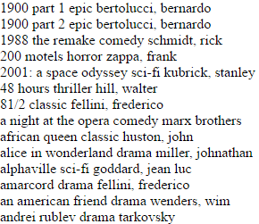

Exercise 4: choosing a record to update from a list
In this exercise, you will query the MySQL table’s nc_category, nc_director and nc_movie using PDO and output the retrieved movie record details to the web browser as before. However, this time you will turn each title into a hyperlink to a separate script, say editMovieForm.php that will allow the user to edit the details of the chosen movie.

To do this we will need to pass the movieID, in the link, as a query string. So for example one of the links (when viewed in the browser source) would be:

<a href='editMovieForm.php?movieID=64'>1900 part 1</a>

The other links would have the movieID for their movie of course.

- Create a new PHP called chooseMovieList.php remembering as always to use the basic HTML core tags as a basis). As for exercise 3, it should query the database and dynamically create a list all the movies making the title a link as shown in the example above. For each movie, in addition to the title, also display the category name and the director’s name

Hints:
- query the nc_category, nc_director and nc_movie tables in a similar way to exercise 3
- loop through the query results and for each movie record object (for each iteration through the while loop), echo the movie details. However, this time the echo should add a link around each title. The link should contain a query string that passes the movieID for the record

An example of the complete html created by echo for one of the records should now look something like:

<div class='movie'>
<span class='title'>
<a href='editMovieForm.php?movieID=64'>1900 part 1</a>
</span>
<span class='categoryName'>epic</span>
<span class='directorName'>bertolucci, bernardo</span>
</div>

When viewed in a web browser the page generated should look something like the image on the right (you could of course use some CSS to improve the layout etc.). | 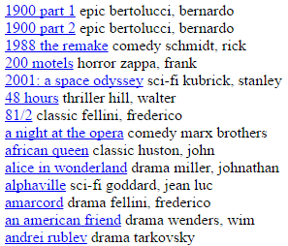

Exercise 5: create a web form to update a record
In this exercise, you will create a new php script that will receive the movieID from the query string sent via the hyperlink clicked in chooseMovieList.php and then use that movieID as part of an SQL query to retrieve all the field values for the relevant record from the nc_movie table. You should then use those field values in a form so that the user can edit them.

- Create a new PHP script called editMovieForm.php (remembering to use the basic HTML core tags as a basis). The script needs to be able to do the following:

  - receive the movieID from the query string sent via the hyperlink clicked in chooseMovieList.php
  - if the user has not chosen a movie (say they have entered the web address for editMovieForm.php directly in the web browser instead), prompt them to do so. Otherwise do c
  - query the nc_movie database table to retrieve the title, category ID, director ID and notes field values for the relevant movie record using PDO. Remember to use the movieID in a WHERE clause so only one record is retrieved
  - start a form whose action is equal to updateMovie.php, (a script to actually update the database that will be called when the form is submitted), i.e.,

echo "<form id='UpdateMovie' action='updateMovie.php' method='get'>";

  - you should then use those field values from c in the form so that the user can edit them, for example

echo "<input type='text' name='title' value='{$rowObj->title}'>";
Where the value of $rowObj->title is that of the title field retrieved from the database.
  - make sure that the user cannot alter the movieID
  - include a submit button in the form
  - end the form

The form should look something like:
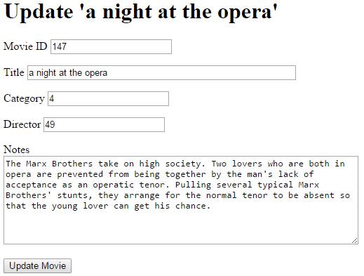

Notice that the categoryID and directorID have been placed in the relevant form fields as we will need them to update the record in the database later. However, it would be better for the user if we instead displayed the category name and director name, and passed the categoryID and directorID to the update script that needs those. We will look at doing that in exercise 6.

- Now you will need to create a script called updateMovie.php (remembering to use the basic HTML core tags as a basis) that the form created by editMovieForm.php calls as its action. This script will execute appropriate SQL to actually update the record being edited. It needs to be able to do the following

  - get all the data from the request stream into variables, preventing undefined index errors, for example

$title = filter_has_var(INPUT_GET, 'title') ? $_GET['title'] : null;

  - prompt the user to enter values for any form fields they may have left blank after editing. Hint: use the empty function, for example

if (empty($title)) {
echo "<p>You have not entered a title</p>\n";
}

  - connect to the database using your re-usable script and function
  - escape any special characters that may have been entered in the form (e.g., ‘ or “ in the title or notes fields). With PDO, you can use a method called quote to do that. For example, we could use the following code for the title field

$title = $dbConn->quote($title);

Later we will look at a better way of doing it using prepared statements
  - assign an SQL update statement to a variable. Remember to use the movieID in a WHERE clause so only one record is updated
  - Execute a query using the variable containing your SQL. Ideally of course you should only update if values for all form fields were provided
  - Display a message if the query executed without error
  - Display a link back to chooseMovieList.php.

Directed learning
If you have time in the workshop attempt the following exercise, otherwise attempt it as directed learning.

Exercise 6: improving the update form
In this exercise, you will improve the update form to assist the user by providing lists of categories and directors to choose from and by displaying the current category and director choices as defaults

- Providing lists to choose from – modify editMovieForm.php so that the user can choose a category from a select list. The select list should be dynamically generated from database content and should have one option for each of the categories in the nc_category table. Do the same for director using the nc_director table. The form should look something like:
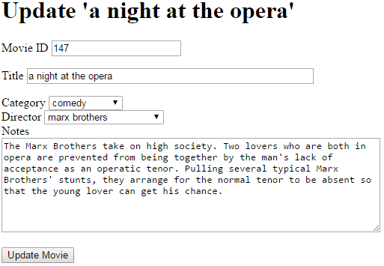

- Displaying default values – now modify editMovieForm.php so that the form initially displays the current category as the default value in a category select list to help the user choose different values if they wish. Do the same for director.

